SOFTWARE CONSTRUCTION AND DEVELOPMENT
Week 4 Laboratory Assignment — Completed Solution
From a Monolithic Program to Cohesive Python Modules
Name: Zoya Farooq Roll No: SU92-BSSEM-S24-059

Part A — Code Archaeology
Every line of the original main() is labelled with the single responsibility it performs. The code has not been changed.
Line of code | Responsibility
name = input("Enter student name: ") | INPUT
marks = [] | CALCULATION (data setup)
for i in range(3): | INPUT (repeat for each subject)
mark = float(input(f"Enter marks for subject {i + 1}: ")) | INPUT
while mark < 0 or mark > 100: | VALIDATION (range rule 0–100)
print("Invalid marks. Enter 0-100.") | VALIDATION (error message; the print is also a display act)
mark = float(input(f"Enter marks for subject {i + 1}: ")) | INPUT (re-prompt)
marks.append(mark) | INPUT (collecting accepted data)
total = sum(marks) | CALCULATION
average = total / len(marks) | CALCULATION
if average >= 80: grade = "A" | GRADING / BUSINESS RULE
elif average >= 70: grade = "B" | GRADING / BUSINESS RULE
elif average >= 60: grade = "C" | GRADING / BUSINESS RULE
elif average >= 50: grade = "D" | GRADING / BUSINESS RULE
else: grade = "F" | GRADING / BUSINESS RULE
print("\nStudent Result") … print("Grade:", grade) | DISPLAY
main() | Program entry point (coordination)

Observation: five different reasons to change the code live inside one function. Changing the pass mark, the layout, or the input method would all force edits to the same place.

Part B — Responsibility Map
Responsibility | What does it do? | Where should it live?
Input | Reads the name and the three marks from the user and converts text to numbers. Re-prompts when a mark is rejected. | main.py (small helper read_mark). It is user-interaction glue; later a GUI could replace it.
Validation | Decides whether a mark is acceptable (0 ≤ mark ≤ 100) and owns the error-message text. | validation.py — validate_mark(mark)
Calculation | Computes the total and the average of the marks. Pure arithmetic, no I/O. | calculations.py — calculate_total, calculate_average
Grading rule | Maps an average to a letter grade using the thresholds 80/70/60/50. It is a business rule that is likely to change. | calculations.py — calculate_grade(average)
Display | Formats and prints the final result. Receives finished values and does no computing. | display.py — display_result(...)

Part C — Design the Modules
Proposed structure (the suggested one is kept; no extra modules were needed):
student_marks/
├── main.py # coordinates the workflow
├── validation.py # input rules + error message
├── calculations.py # total, average, grade
└── display.py # output formatting

1. Why does each module exist?
- main.py — orchestrates the steps in order (input → validate → calculate → display). It contains no rules itself.
- validation.py — holds the rules about what data is acceptable. These rules change independently of the arithmetic or the screen layout.
- calculations.py — holds the business logic (total, average, grade). It can be tested without a keyboard or a screen.
- display.py — holds the presentation. Swapping console output for a GUI or a web page touches only this module.
2. Which functions belong in calculations.py?
calculate_total(marks), calculate_average(marks) and calculate_grade(average). All three transform data into data, with no input() or print(). The grade belongs here because the grading scale is a business rule, not a presentation detail.
3. Should display.py calculate the grade? Why?
No. display.py should only show values it is given. If it calculated the grade, a change to the grading scale would require editing the display code, and a GUI replacement would have to duplicate the grading rule (leading to inconsistent results). Computing in calculations.py keeps one source of truth and keeps display.py replaceable.
4. What should main.py coordinate?
The sequence of the workflow: ask for the name; collect each mark and re-prompt until validate_mark accepts it; call calculate_total, calculate_average and calculate_grade; pass the results to display_result. main.py knows what happens and in which order, but not how each step is done.
5. Which implementation details should other modules not need to know?
- The grade thresholds (80/70/60/50) — hidden inside calculate_grade; callers just receive a letter.
- The valid range 0–100 and the wording of the error — hidden inside validation.py.
- How the average is computed (sum / len) — hidden in calculations.py.
- How results are formatted or printed (print calls, dashes, labels) — hidden in display.py.
- Where the data came from (console, file, GUI) — calculations.py and display.py never see this.

Part D — Implementation
The program was split into four modules with no change in behaviour. Each file is shown in full below.

validation.py
"""validation.py - rules that decide whether input data is acceptable."""

MIN_MARK = 0
MAX_MARK = 100
INVALID_MARK_MESSAGE = "Invalid marks. Enter 0-100."

def validate_mark(mark):
"""Return True if mark lies within the allowed range (inclusive)."""
return MIN_MARK <= mark <= MAX_MARK

calculations.py
"""calculations.py - pure business logic: totals, averages and grading.
No input() or print() calls appear here."""

def calculate_total(marks):
return sum(marks)

def calculate_average(marks):
return calculate_total(marks) / len(marks)

def calculate_grade(average):
if average >= 80:
return "A"
elif average >= 70:
return "B"
elif average >= 60:
return "C"
elif average >= 50:
return "D"
else:
return "F"

display.py
"""display.py - presentation of the result. Receives finished values only."""

def display_result(name, total, average, grade):
print("\nStudent Result")
print("---------------")
print("Name:", name)
print("Total:", total)
print("Average:", average)
print("Grade:", grade)

main.py
"""main.py - coordinates the application: input -> validate -> calculate -> display."""
from validation import validate_mark, INVALID_MARK_MESSAGE
from calculations import calculate_total, calculate_average, calculate_grade
from display import display_result

NUMBER_OF_SUBJECTS = 3

def read_mark(subject_number):
"""Prompt until the user enters a mark that passes validation."""
mark = float(input(f"Enter marks for subject {subject_number}: "))
while not validate_mark(mark):
print(INVALID_MARK_MESSAGE)
mark = float(input(f"Enter marks for subject {subject_number}: "))
return mark

def main():
name = input("Enter student name: ")
marks = [read_mark(i + 1) for i in range(NUMBER_OF_SUBJECTS)]

total = calculate_total(marks)
average = calculate_average(marks)
grade = calculate_grade(average)

display_result(name, total, average, grade)

if __name__ == "__main__":
main()

Design notes.
- validate_mark returns True/False rather than printing. Validation decides, main.py acts on the decision, so validation.py has no dependency on the console.
- The error text INVALID_MARK_MESSAGE lives in validation.py next to the rule it describes, so rule and message change together (see Change 3).
- The prompt/re-prompt loop is kept in a small read_mark() helper in main.py. It is interaction glue, and keeping it out of the calculation and display modules means those have no input() calls.
- Output text is identical to the original program, including values such as "Total: 225.0".

Part E — Dependency Mapping
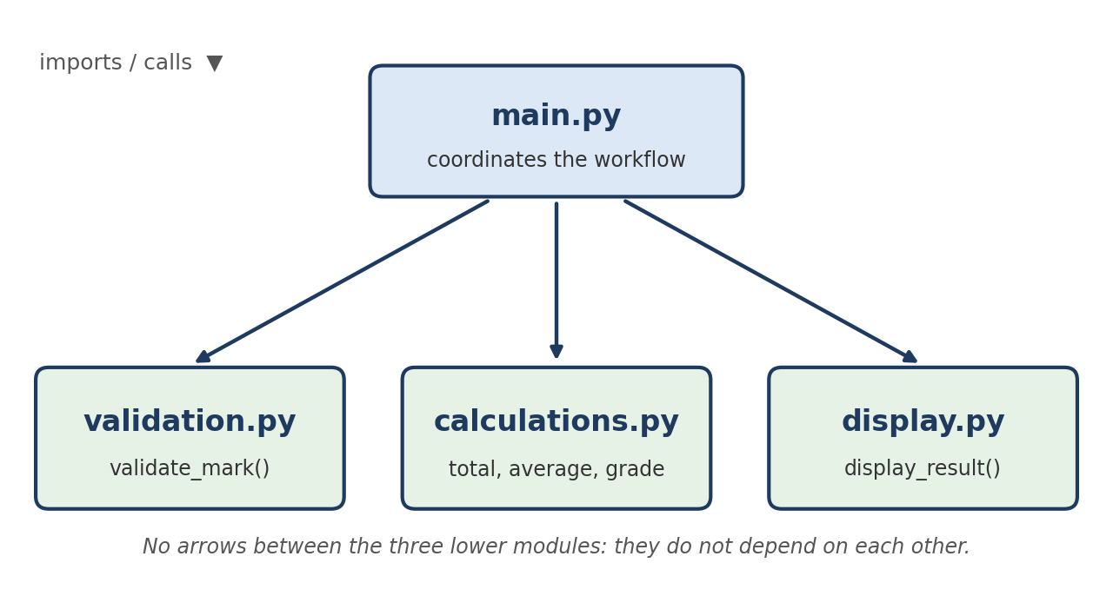
Figure 1: Dependency diagram (arrow = "imports / calls")
Dependency table
Module | Depends on | Depended on by
main.py | validation, calculations, display | nobody (entry point)
validation.py | nothing | main.py
calculations.py | nothing | main.py
display.py | nothing | main.py

6. Which modules does main.py depend on?
All three: validation.py (validate_mark, INVALID_MARK_MESSAGE), calculations.py (calculate_total, calculate_average, calculate_grade) and display.py (display_result).
7. Does display.py need to know how the grade is calculated?
No. It receives the finished grade string as a parameter and prints it. It does not import calculations.py.
8. Does calculations.py need to know how results are printed?
No. It only returns values. It has no print statements and does not import display.py, so it is reusable in any interface.
9. What would happen if display.py were replaced by a GUI?
Only display.py (or the single import line in main.py) would change. As long as the replacement exposes display_result(name, total, average, grade), validation.py and calculations.py stay untouched and their logic is reused exactly as is.
10. Which dependencies are necessary and which would be unnecessary?
- Necessary: main.py → validation, main.py → calculations, main.py → display. A coordinator must know the modules it coordinates.
- Unnecessary (avoided): display → calculations (display would recalculate or call the grade function itself), calculations → display (printing from logic), validation → display (printing the error from the rule), and calculations ↔ validation. Any of these would create hidden links that make one change ripple into several modules.

Part F — Change Request Test
Change | Request | Module to change | Why
Change 1 | Grading becomes A ≥ 85, B ≥ 75, C ≥ 65, D ≥ 55 | calculations.py (calculate_grade only) | The thresholds are a business rule that lives only in calculate_grade.
Change 2 | Result format changes | display.py | Presentation is isolated there; calculation and validation are not affected.
Change 3 | Validation message changes | validation.py (INVALID_MARK_MESSAGE) | The message sits beside the rule it describes. main.py just shows whatever text it is given.
Change 4 | Results shown through a GUI later | display.py replaced / a new GUI module | Everything in calculations.py and validation.py stays as it is.

Change 1 — exact edit. Only these lines in calculations.py change:
def calculate_grade(average):
if average >= 85:
return "A"
elif average >= 75:
return "B"
elif average >= 65:
return "C"
elif average >= 55:
return "D"
else:
return "F"

Change 4 — what should be replaceable? The whole presentation layer: display_result (and, if the GUI also collects data, the console prompts in main.py’s read_mark helper). The calculation logic, the grading rule and the validation rule are called in the same way regardless of the interface, so they are not modified.

Part G — Verification
The original monolithic program and the modular program were both run with each input set, and their outputs were compared character by character. In every case the output was identical (prompts omitted below for readability).
Test case | Marks entered | Total | Average | Grade | Matches original
Normal (Ayesha) | 75, 82, 68 | 225.0 | 75.0 | B | Yes
Boundary A (Sara) | 80, 80, 80 | 240.0 | 80.0 | A | Yes
Boundary B (Ali) | 70, 70, 70 | 210.0 | 70.0 | B | Yes
Boundary C (Dina) | 60, 60, 60 | 180.0 | 60.0 | C | Yes
Boundary D (Eve) | 50, 50, 50 | 150.0 | 50.0 | D | Yes
Invalid, then valid (Omar) | -5 ✗, 105 ✗, then 90, 70, 80 | 240.0 | 80.0 | A | Yes
Second student (Zain) | 40, 45, 30 | 115.0 | 38.333333333333336 | F | Yes
Second student (Hira) | 90, 85, 95 | 270.0 | 90.0 | A | Yes

Sample run — invalid marks (Omar):
Enter student name: Omar
Enter marks for subject 1: -5
Invalid marks. Enter 0-100.
Enter marks for subject 1: 105
Invalid marks. Enter 0-100.
Enter marks for subject 1: 90
Enter marks for subject 2: 70
Enter marks for subject 3: 80

Student Result
---------------
Name: Omar
Total: 240.0
Average: 80.0
Grade: A

Sample run — normal marks (Ayesha):
Enter student name: Ayesha
Enter marks for subject 1: 75
Enter marks for subject 2: 82
Enter marks for subject 3: 68

Student Result
---------------
Name: Ayesha
Total: 225.0
Average: 75.0
Grade: B

Note on boundaries. The grade is based on the average, so the boundaries 50, 60, 70 and 80 were tested by entering three equal marks (average exactly on the boundary). Each boundary lands in the higher grade (>=), exactly as in the original code. The marks 0 and 100 are also accepted by validate_mark, and -5 and 105 are rejected.

Reflection
15. Functions vs modules.
A function groups a few statements into one reusable action inside a file. A module groups related functions and constants into a separate file with its own namespace and a clear responsibility. Functions organise code; modules organise responsibilities and set boundaries (what is imported, what is hidden), which limits how far a change can spread.
16. Strongest cohesion.
validation.py (and display.py) are the most cohesive: every element serves one purpose (deciding if a mark is acceptable / presenting the result). calculations.py is also cohesive, since all three functions are pure business logic about marks. validation.py is the strongest because its constants, message and function all exist for the single rule “is this mark acceptable?”.
17. Example of coupling.
main.py is coupled to display_result’s parameter list (name, total, average, grade): if the function’s signature changes, main.py must change. It is also coupled to validation.py through INVALID_MARK_MESSAGE. This is acceptable, low (data) coupling: only simple values are passed, and no module reaches into another’s internals.
18. How modularity helps when requirements change.
Each change request in Part F was confined to one module: grading → calculations.py, format → display.py, message → validation.py, GUI → display layer. Developers can find, change and test the affected code without re-reading or risking the rest, and the modules can be tested separately (for example, calculate_grade(80) can be unit-tested without any typing).
19. Too broad or too small?
No module is too small. calculations.py is the broadest, since it mixes arithmetic and the grading rule. For a larger system the grading rule could move into its own grading.py (the likely-to-change area per McConnell). For this small program one module is enough, and splitting further would add files without adding clarity. The input prompts stayed in main.py; if a GUI were added, they could be separated into an input module.

Semester Project Connection
Template for the semester project sketch (fill in with your own project). The same reasoning is used rather than copying the Student Marks layout:
Major responsibility | Possible module | Main dependencies
User interface / interaction | ui (or views) | depends on services
Business rules / core logic | services (or logic) | depends on models; must not depend on ui
Data representation | models | depends on nothing
Storage / persistence | storage (or repository) | depends on models
Validation | validation | depends on nothing
Application startup / coordination | main (or app) | depends on ui, services, storage

Rule of thumb: dependencies point inward toward stable code (models and rules), never from rules back to the screen or the database.

Deliverables Checklist
- Completed modular Python project — Part D (main.py, validation.py, calculations.py, display.py), verified against the original.
- Responsibility map — Part B.
- Dependency diagram — Part E, Figure 1.
- Change Request Test answers — Part F.
- Short reflection — Reflection section.

